**Module 1 – Introduction to Deep Learning**

## **Lesson Introduction**

Welcome to Module 1 of our Deep Learning course.  
 In this module, we will understand what Deep Learning is, why it matters, how it is different from traditional machine learning, and set up the tools needed to get started.

## **Mini Agenda**

1. What is Deep Learning & Why It Matters
2. Neural Networks vs Traditional ML
3. Biological vs Artificial Neurons
4. Applications in Industry (CV, NLP, Speech, Generative AI)
5. Installing Deep Learning Frameworks (PyTorch, TensorFlow/Keras)
6. Setting up GPU Environment (Colab / Kaggle / Local CUDA)

## **Real-World Hook**

* How does Google Photos recognize your face automatically?
* How does ChatGPT generate human-like answers?
* How does Tesla’s self-driving car detect pedestrians and traffic signs?

The answer to all of these is **Deep Learning**.

## **Introduce Topic as a Solution**

Traditional ML struggles with **unstructured data** like images, audio, and video.  
 Deep Learning can **automatically learn features** from raw data, making it the go-to solution for complex, large-scale AI problems.

## 

## **Theory Explanation**

### **1. What is Deep Learning & Why It Matters**

* **What:** A subfield of Machine Learning that uses **multi-layered neural networks** to automatically learn from data.
* **Why:** Handles massive and complex datasets efficiently without manual feature engineering.
* **When:** Ideal for large datasets, unstructured data, and tasks needing high accuracy.
* **How:** Stacks layers of artificial neurons that transform inputs step-by-step into outputs.
* **Example:** Image classification with Convolutional Neural Networks (CNNs).

**Advantages:**

* Learns automatically from raw data
* Highly accurate with large datasets
* Works well with images, text, and audio

**Disadvantages:**

* Needs large datasets and high computation power
* Harder to interpret results

**Limitations & How to Overcome:**

* Limitation: Long training time → Solution: Use GPUs/TPUs
* Limitation: Overfitting → Solution: Regularization, dropout

### **2. Neural Networks vs Traditional ML**

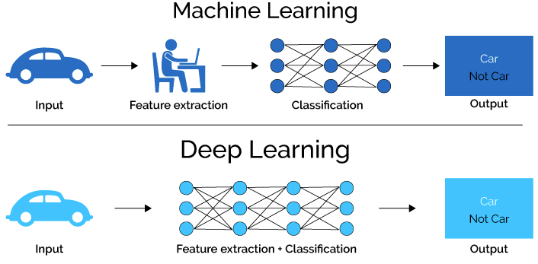

| **Feature** | **Traditional ML** | **Deep Learning** |
| --- | --- | --- |
| Feature Engineering | Manual | Automatic |
| Data Size Requirement | Small to medium | Large |
| Computation Requirement | Low to medium | High |
| Interpretability | Easy | Difficult |

### **3. Biological vs Artificial Neurons**

**Biological Neuron:** Dendrites → Soma → Axon → Synapse  
 **Artificial Neuron:** Inputs → Weights → Sum → Activation Function → Output

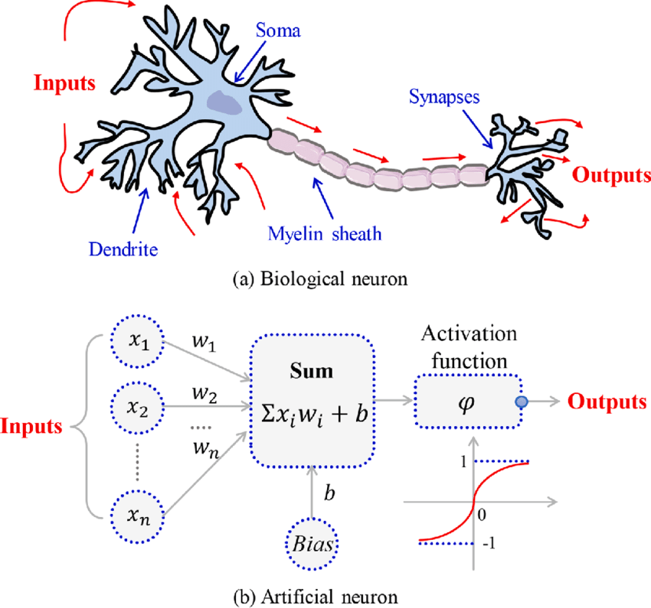

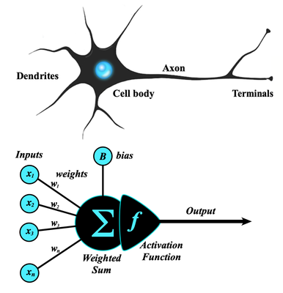

Mathematically:

y=f(∑(wi⋅xi)+b)y = f\left( \sum (w_i \cdot x_i) + b \right)

### 

### **4. Applications in Industry**

* **Computer Vision (CV):** Face recognition, object detection
* **Natural Language Processing (NLP):** Chatbots, translation
* **Speech:** Voice assistants, transcription
* **Generative AI:** Text-to-image, AI music creation

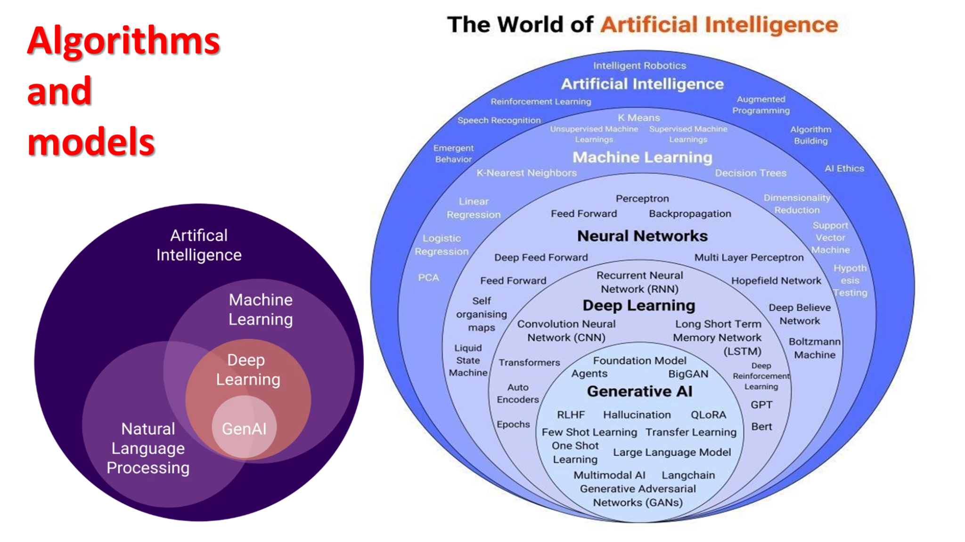

### **5. Installing Deep Learning Frameworks**

**PyTorch (Preferred):**

pip install torch torchvision torchaudio

**TensorFlow/Keras:**

pip install tensorflow

### **6. Setting up GPU Environment**

* **Google Colab:** Free GPU access
* **Kaggle Notebooks:** Free GPU + datasets
* **Local CUDA:** Install NVIDIA drivers, CUDA Toolkit, cuDNN

## **Business Scenario**

An e-commerce company uses CNNs to detect whether a product image uploaded by sellers is clear and follows guidelines before listing.

## **Practice Session**

1. Explain the difference between ML & DL.
2. List two advantages of Deep Learning.
3. Install PyTorch on Colab and verify GPU.
4. Draw the structure of a biological neuron.
5. Identify a real-world use case for NLP.

## **Assignments**

1. Install TensorFlow and train a simple image classifier.
2. Compare training speed on CPU vs GPU in Colab.

## **Quiz**

1. What is the main advantage of Deep Learning over traditional ML?
2. Name one popular Deep Learning framework.
3. What hardware component is most useful for training large DL models?

## **Interview Questions**

### **Theoretical**

1. Define Deep Learning.
2. Difference between CNN and RNN.  
    ... (total 10)

### **Practical**

1. Write PyTorch code to create a linear layer.  
    ... (total 10)

## **Resources**

* [PyTorch](https://pytorch.org/)
* [TensorFlow](https://www.tensorflow.org/)
* [Google Colab](https://colab.research.google.com/)

IN FUTURE WE LEARN

